**Lab 8   
Deploying to and Running SpringBoot Applications on Oracle Cloud**

This lab will show you how you can deploy your SpringBoot application to and run it on the Oracle Cloud. There are several cloud services that we can leverage for running a SpringBoot application:

* Container Cloud Service – for running anything in a Docker Container, including a SpringBoot application (as discussed in lab 4)
* Application Container Cloud – for running an application in a prepared runtime (in our case Java; other runtimes available for ACC include Node, Ruby, Python, Go and PHP)
* Other options include IaaS Compute, Java Cloud Service (based on WebLogic) and the upcoming Container Engine Cloud (Kubernetes); the Fn Platform for serverless functions could provide another deployment target – which could be either cloud based or running on premises

In this lab we will focus on Application Container Cloud.

Note: you can either make use of your own cloud environment – for example acquired through the $300 trial program at [cloud.oracle.com](https://cloud.oracle.com/en_US/tryit) – or one that has been prepared for this workshop. In the latter case, ask the instructor for the credentials for the cloud environment.

You will need these details:

* Cloud Identity Domain
* Region
* Username
* Password

# Starting point

The starting point for this lab is the service that created made in Lab 1 – the DroneBuzzers API. The code of this service is located in directory lab 8/dronebuzzers.

The *lab 8/input* directory contains supporting files that are required for the deployment to ACCS.

# Create the ACC deployment package

The package that we deploy to the Application Container Cloud is an archive (zip or tar) that contains the application’s jar file and one or two meta-data files that describe the application, how it should be deployed and started and how it should be scaled.

The file manifest.json in the lab 8/input directory is one such meta-data file. It specifies the runtime for the application – Java 8 – and the command used to run the application.

From the Spring documentation:

By default, SpringApplication converts any command line option arguments (that is, arguments starting with --, such as --server.port=9000) to a propertyand adds them to the Spring Environment. As mentioned previously, command line properties always take precedence over other property sources.

In order to have Spring listen at the port that is available (for example through the Application Container Cloud runtime environment) we have to make sure we define that port at the command line through the argument –server.port. This corresponds with the content of the command entry in the manifest.json file:  
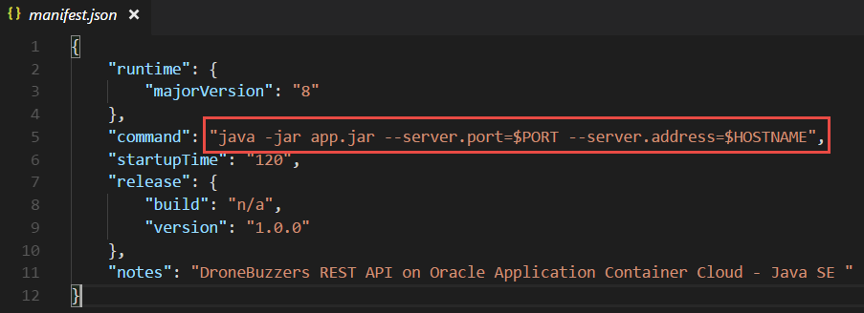

The reference $PORT is to an environment variable that ACCS sets at runtime.

The server.address command line parameter that takes its value from another runtime environment variable $HOSTNAME is passed to Spring as well at startup time.

The second meta-data file is called deployment.json. This file is optional – we will omit it here. The deployment.json file specifies how much memory to allocate to the application, how many application instances to create initially, additional environment variables, and service bindings to other Oracle Cloud services. You can specify these same options from the user interface, or you can upload this file using the REST API. If no values are specified or the file is omitted, memory and instance defaults are used.

Copy the manifest.json from directory lab 8/input to lab 8/dronebuzzers/src/main/resources – the directory that also contains the application.properties file.

# Create a Deployable Distribution for the Spring Boot Application

The package we will deploy to the Application Container Cloud contains the manifest.json file as well as the JAR file for the Spring Boot application – that must contain all its dependencies!

To create that distribution package – and the JAR file with all dependencies for the Spring Boot application - we make use of Maven. The pom.xml file in directory lab 8/dronebuzzers describes the application and can be run to build a simple JAR file, using:

mvn package

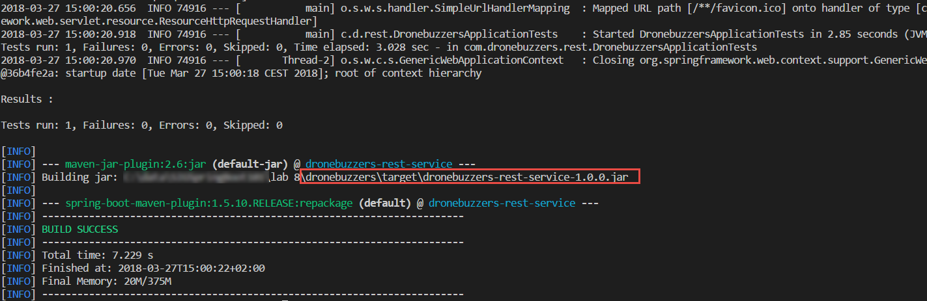

This will run for a little while before completing with the BUILD SUCCESS message. A few lines earlier, Maven will have reported the creation of a jar file. This files I located in directory lab 8/dronebuzzers/target and is called (after the artifactId and version specified in the pom.xml file) dronebuzzers-rest-service-1.0.0.jar.

However: ***this file does not contain all dependencies***.

So instead, we will make use of a special Maven plugin to create the fully independent self contained JAR that we are looking for.

Add the contents of the file lab 8/input/add-to-pom.xml to the plugins sections of the pom.xml file in lab 8/dronebuzzers.

Look at the plugin you have added: it refers to a file called deploy.xml. This file in turn determines what kind of end result Maven should bake. In this case, we want a final zip-file that contains the self contained JAR file as well as the manifest.json file. Copy file deploy.xml from lab 8/input to lab 8/dronebuzzers. Check the contents of this file:

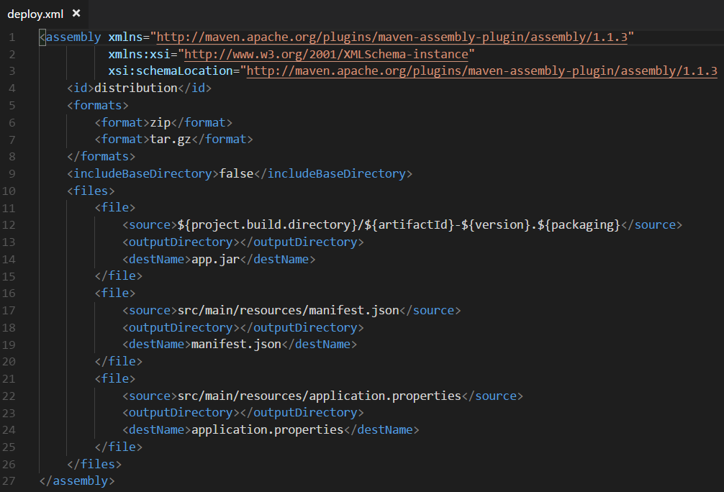

Deploy.xml instructs the Maven Assembly plugin to produce two files in the target directory (lab 8/dronebuzzers/target - a tar.gz and a zip file (dronebuzzersAPI.zip and dronebuzzersAPI.tar.gz) – that both contain the self-contained jar-file (app.jar) and the manifest.json and application.properties file.

After making these changes, run again

mvn package

It will now run a for a little bit longer and create the two distribution packages in zip and tar.gz format:

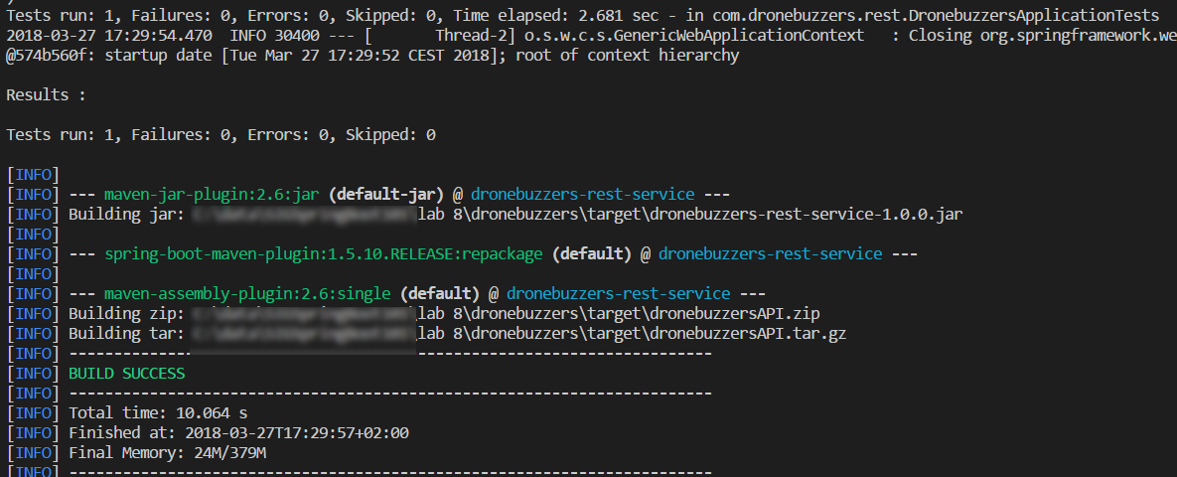

Note: these distribution packages are substantially bigger than the earlier outcome of the Maven build.

# Deploy the Application Archive to ACC through the Service Console

The application can be deployed to ACC through the PSM command line tool or through the browser based console. You would use PSM in any automated scenario. For now we will just use the user interface to upload and deploy the application to its runtime container on ACCS.

Login to the Oracle Cloud environment and open the Service Console for Application Container Cloud (<https://apaas.us.oraclecloud.com/apaas/faces/aPaaSRunner.jspx> for Region US).

Click on Create Application. Then click on Java SE as the runtime of choice:

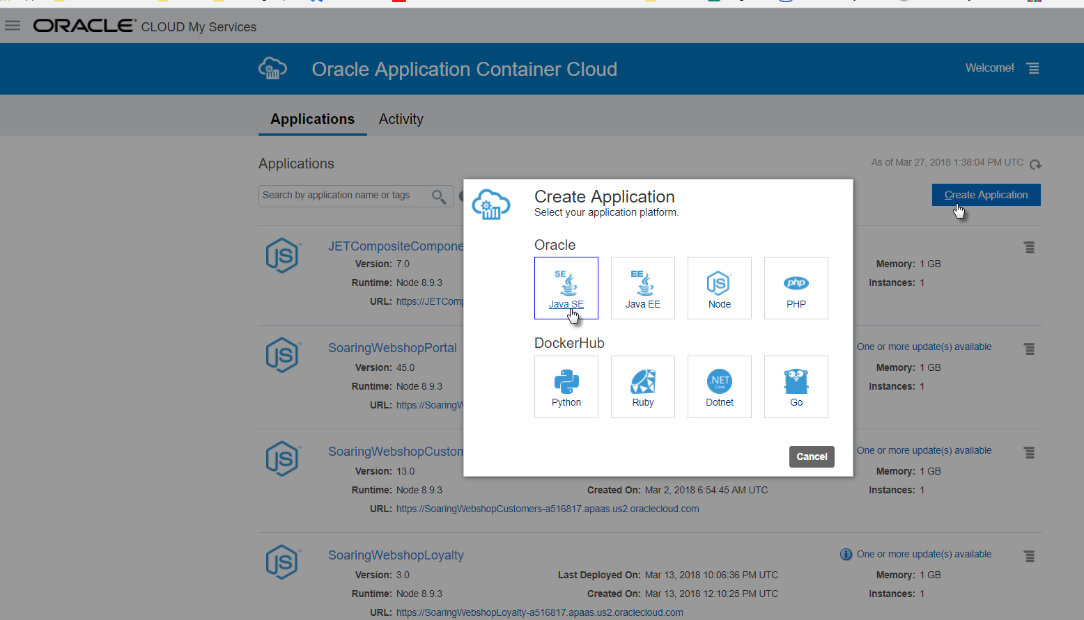

A popup window is presented. Here you need to specify the name of the application and upload the zip (or tar) file that contains the application (and the manifest.json file). You can change the settings for number of instances and the allocated memory. Let’s start small.

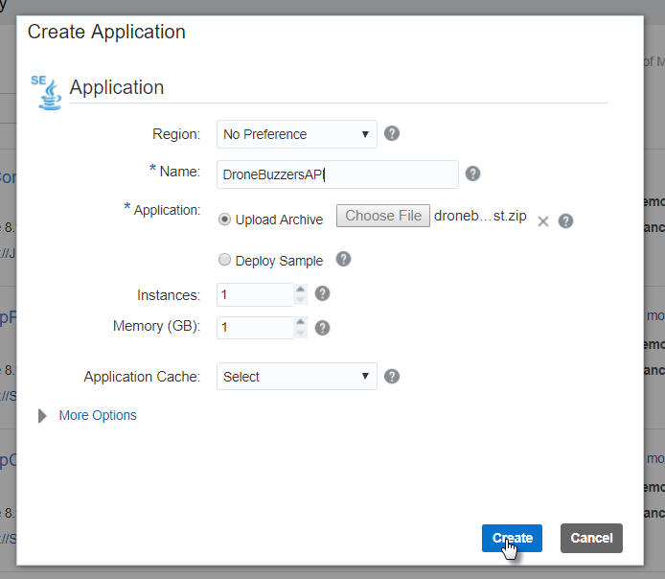

Click on Create to start the deployment process.

Let’s wait a little until the uploaded archive is processed and validated:

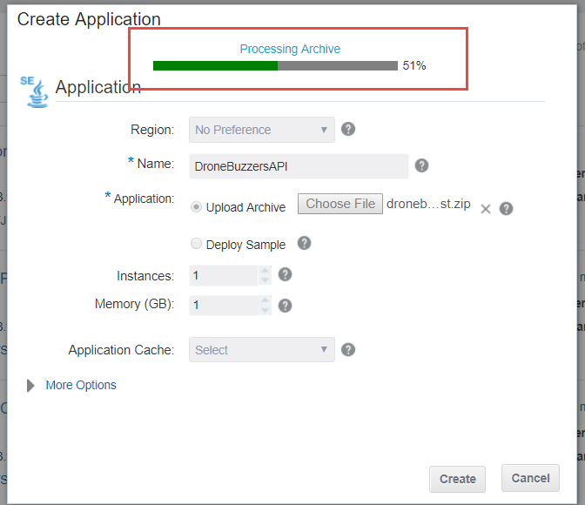

And wait a little longer for the actual deployment:

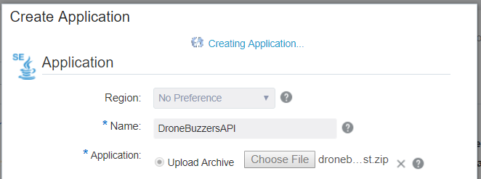

After a little while, the application creation request is being processed for real:

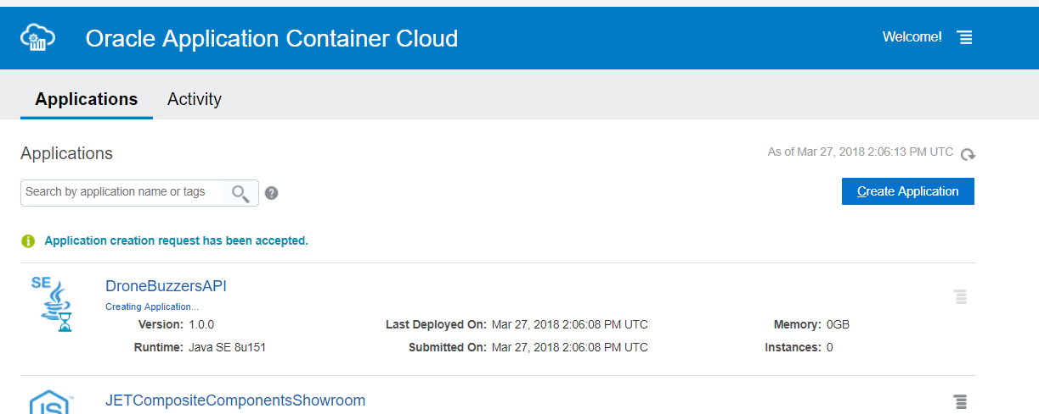

After 1-3 minutes, the application will be up and running. Unless it is not, and we have to inspect log files to find out what failed and why.

When the application container is fully prepared, the public URL is provided:

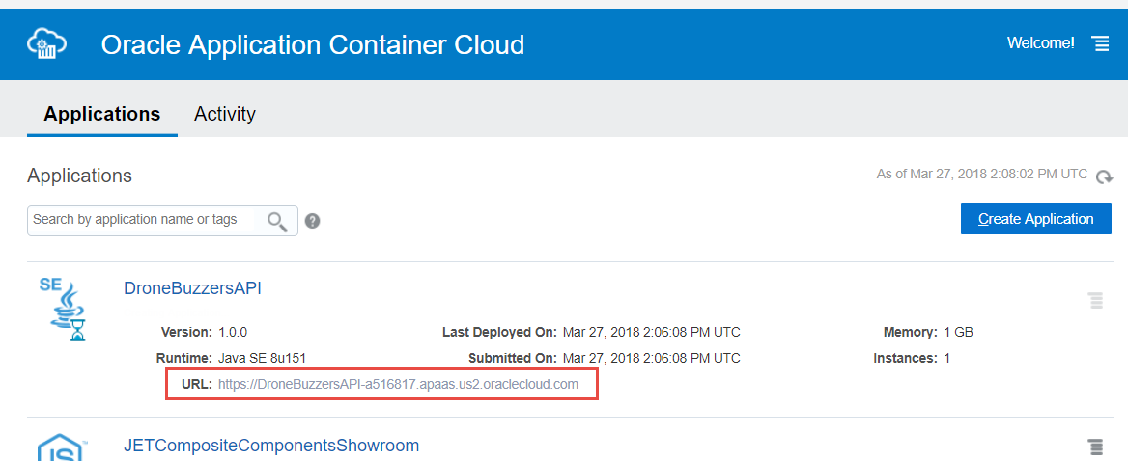

After creation is complete, you can check details of the application by clicking on the name. You will information such as this:

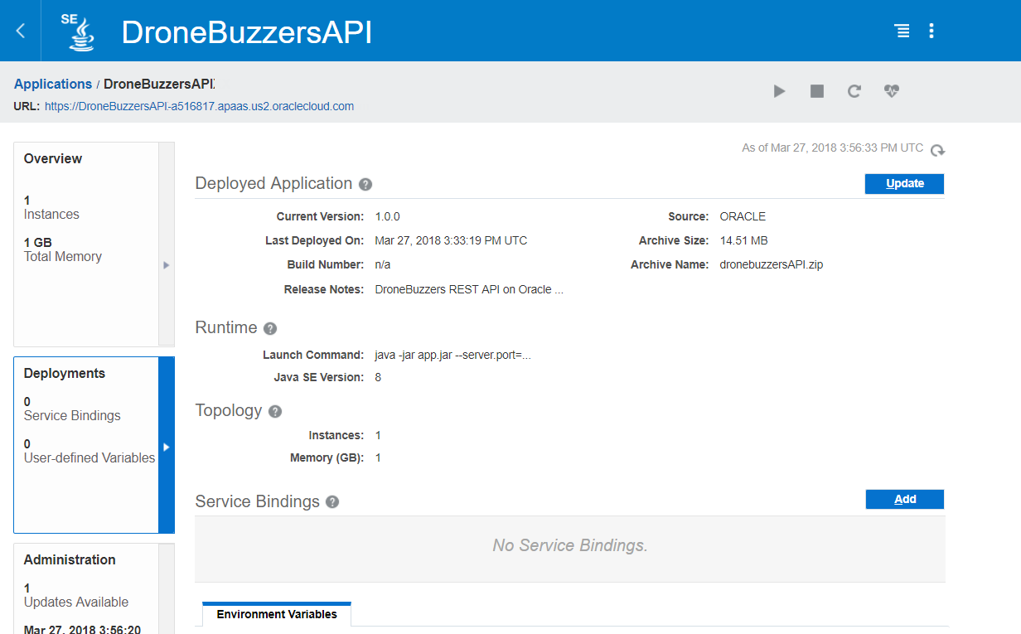

# Testing the DroneBuzzersAPI on the Cloud

Now we can try to access the DroneBuzzersAPI as it is running on the Public Cloud.

If you just click on the URL – or copy and paste it into your browser – you will get a response like this:

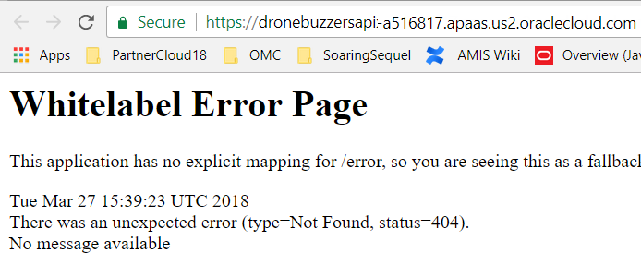

However, just by adding /dronebuzzers/part to the URL, you will get a list of all parts:

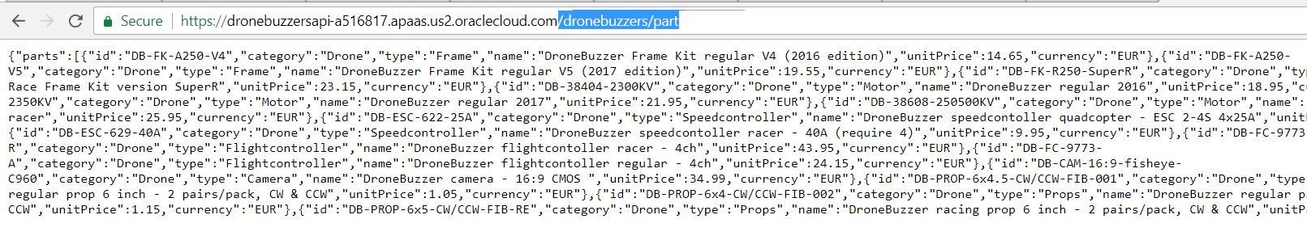

Now would be a good time to return to the Postman collection we have used for testing the DroneBuzzers API in lab 1. Change the endpoint of the API to the URL defined in the Oracle Container Cloud service, and you should be able to run through all requests.

Open Postman and import the file SigSpringBoot101 - lab 8.postman_collection.json from directory lab 8/postman.

You will see five requests – that you cannot actually execute, because they all depend on an environment variable called DRONEBUZZER_API_ENDPOINT.

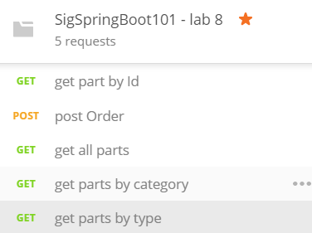

Create a new environment in Postman and define a key DRONEBUZZER_API_ENDPOINT that should be set to the value of your Application’s URL on Application Container Cloud:

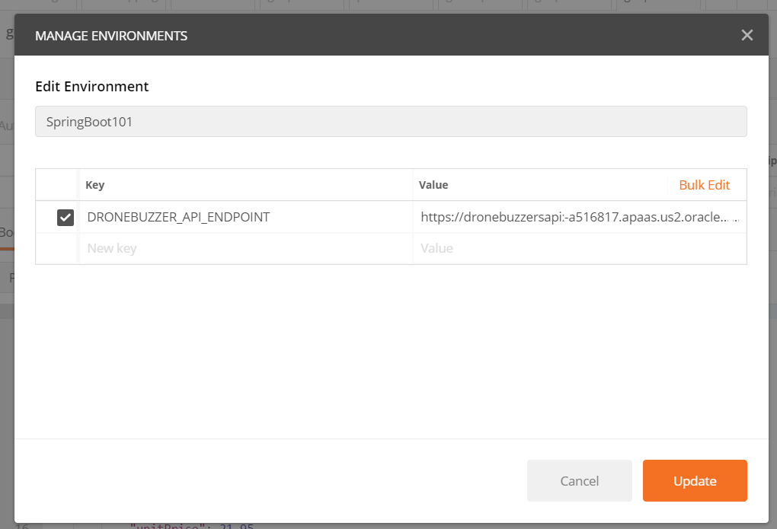

Now you can execute the requests and in doing so test the DroneBuzzerAPI, running on ACC:

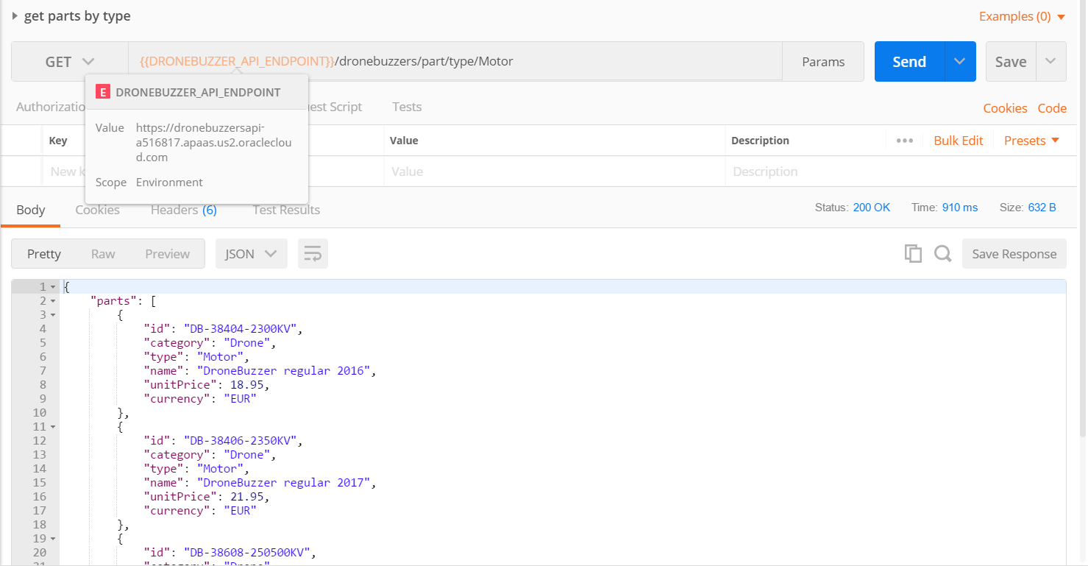

You have managed to take the vanilla Spring Boot application created in Lab 1 and deployed it successfully on Application Container Cloud. Crucial are the correct packaging of the Spring Boot application in a self-contained JAR file and the appropriate configuration of the manifest.json file that is the instruction for ACC.

# Additional pointers

Some resources that may be helpful when looking into combination of SpringBoot and Oracle Application Container Cloud:

* Blog: Carsten Wiesbaum: Spring-Boot and Oracle Application Container Cloud - <http://www.esentri.com/blog/2017/04/12/spring-boot-and-oracle-application-container-cloud/>
* Blog: Carsten Wiesbaum: Deploy to ACC with Maven - <https://www.esentri.com/blog/2017/06/28/deploy-to-oracle-application-container-cloud-using-maven/>
* Spring Boot Documentation - How to Externalize SpringBoot properties (such as port): <https://docs.spring.io/spring-boot/docs/current/reference/html/boot-features-external-config.html>
* Medium Article: Vinay Kumar -Deploying a Spring Boot Microservice to Application Container —Oracle Cloud (<https://medium.com/oracledevs/deploying-a-spring-boot-micro-services-application-to-oracle-application-container-cloud-95238f1b7ab7> )
* Blog: Maarten Smeets: Application Container Cloud Service (ACCS): Using the Application Cache from a Spring Boot application (<http://javaoraclesoa.blogspot.nl/2018/03/application-container-cloud-service.html> )
* Medium Article: Abhishek Gupta - Using Prometheus to monitor [Spring Boot] apps on Oracle Application Container Cloud (<https://medium.com/oracledevs/using-prometheus-to-monitor-apps-on-oracle-cloud-7b75dea9f2f3> )
* Documentation Oracle Application Container Cloud Service and Java SE applications: <https://docs.oracle.com/en/cloud/paas/app-container-cloud/create-sample-java-se-applications.html>
* Documentation on Meta Data Files for Applications deployed to Application Container Cloud - <https://docs.oracle.com/en/cloud/paas/app-container-cloud/dvcjv/creating-meta-data-files.html>